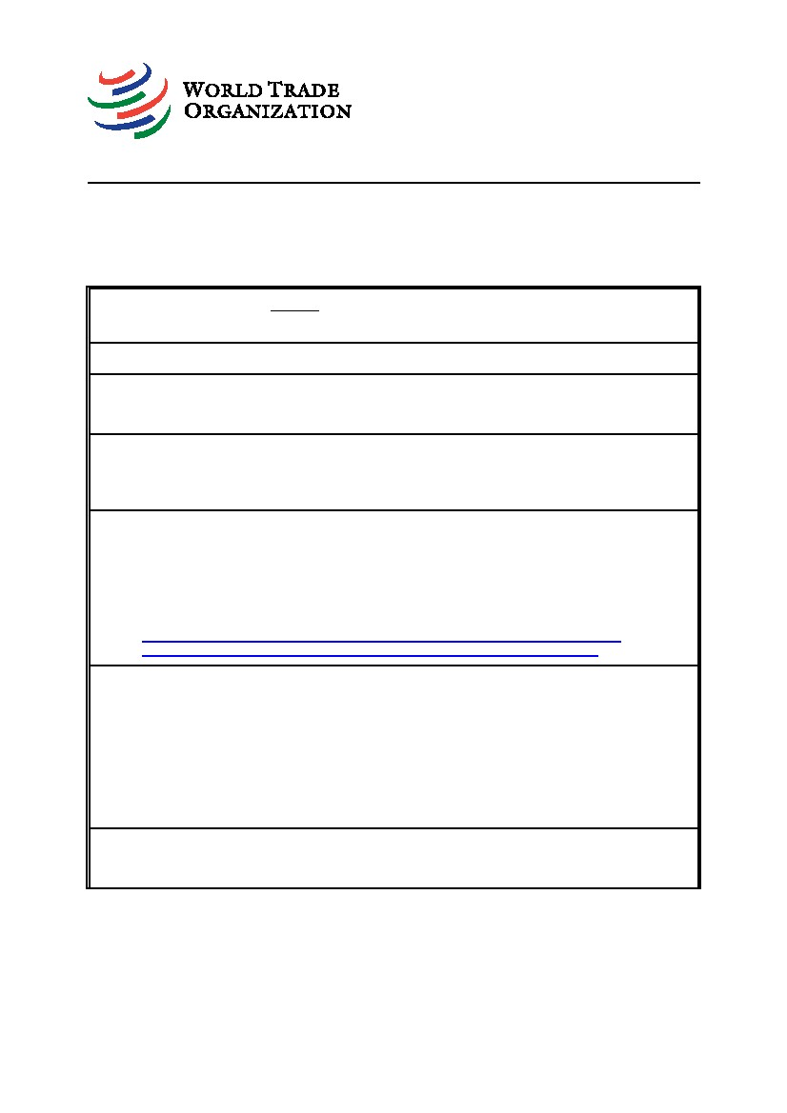
G/SPS/N/MEX/238
18 June 2013
(13-3141)
Committee on Sanitary and Phytosanitary Measures
Page: 1/2
Original: Spanish
NOTIFICATION
1.
Notifying Member: MEXICO
If applicable, name of local government involved:
2.
3.
Agency responsible: Secretaría de Salud (Ministry of Health)
Products covered (provide tariff item number(s) as specified in national
schedules deposited with the WTO; ICS numbers should be provided in addition,
where applicable): Consumer products containing lead compounds
Regions or countries likely to be affected, to the extent relevant or practicable:
[X]
[]
5.
All trading partners
Specific regions or countries:
4.
Title of the notified document: Proyecto de Norma Oficial Mexicana PROY-NOM-004-
SSA1-2013, "Salud ambiental. Limitaciones y especificaciones sanitarias para el uso y
comercialización de los compuestos de plomo en productos de consumo" (Draft Mexican
Official Standard PROY-NOM-004-SSA1-2013, "Environmental health. Restrictions on and
sanitary requirements for the use and marketing of lead compounds in consumer
products") Language(s): Spanish Number of pages: 5
Text available at:
http://www.dof.gob.mx/nota_detalle.php?codigo=5302353&fecha=13/06/2013
http://members.wto.org/crnattachments/2013/sps/MEX/13_2282_00_s.pdf
6.
Description of content: The notified Standard establishes the restrictions on and sanitary
requirements for the use and marketing of domestic and/or imported consumer products
containing lead compounds, in order to prevent adverse effects on health.
Compliance with this Standard is binding throughout Mexican territory on natural and legal
persons using and/or marketing domestic or imported consumer products containing lead
compounds, in order to prevent adverse effects on health.
The notified Standard does not apply to foodstuffs of any kind, health-related inputs,
medical devices, pesticides, plant nutrients, additives or perfume and beauty products, the
lead content of which is regulated by the relevant Mexican Official Standards.
7.
Objective and rationale: [X] food safety, [ ] animal health, [ ] plant protection,
[X] protect humans from animal/plant pest or disease, [ ] protect territory from
other damage from pests.
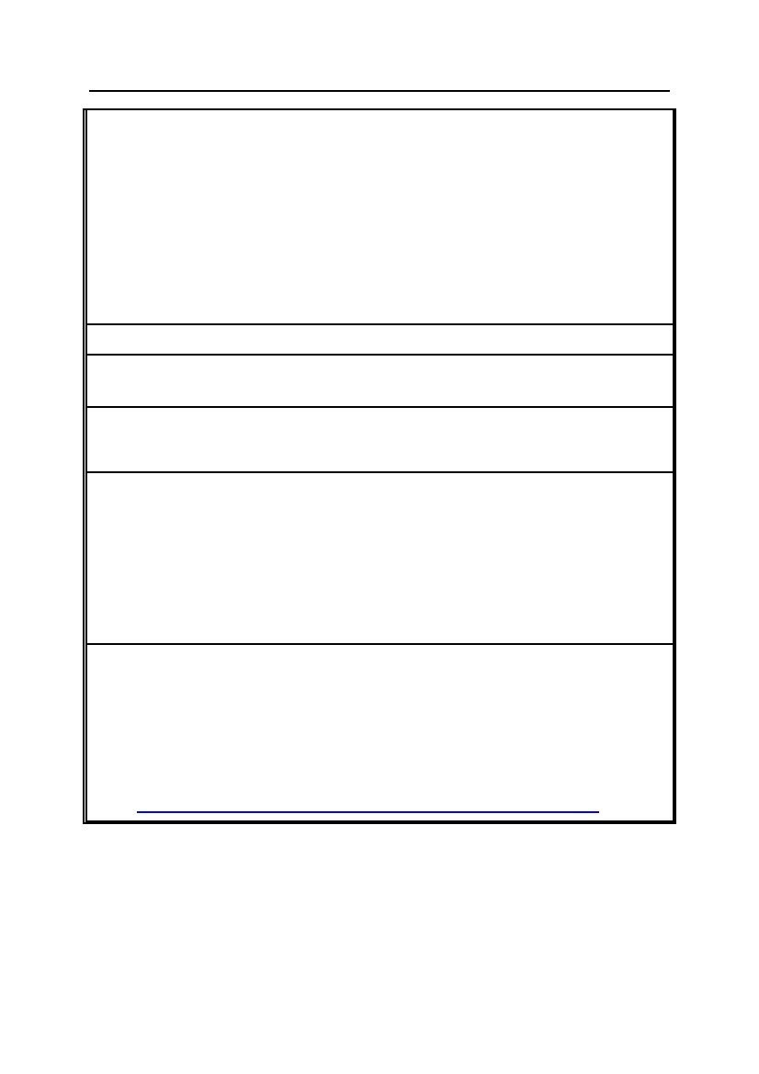
G/SPS/N/MEX/238
-2-
8.
Is there a relevant international standard? If so, identify the standard:
[]
[]
[]
[X]
Codex Alimentarius Commission (e.g. title or serial number of Codex
standard or related text)
World Organization for Animal Health (OIE) (e.g. Terrestrial or Aquatic
Animal Health Code, chapter number)
International Plant Protection Convention (e.g. ISPM No.)
None
Does this proposed regulation conform to the relevant international standard?
[ ] Yes [ ] No
If no, describe, whenever possible, how and why it deviates from the
international standard:
9.
10.
Other relevant documents and language(s) in which these are available:
Proposed date of adoption (dd/mm/yy): To be determined
Proposed date of publication (dd/mm/yy): To be determined
11.
Proposed date of entry into force: [ ] Six months from date of publication, and/or
(dd/mm/yy): To be determined
[X] Trade facilitating measure
12.
Final date for comments: [ ] Sixty days from the date of circulation of the
notification and/or (dd/mm/yy): 11 August 2013
Agency or authority designated to handle comments: [X] National Notification
Authority, [ ] National Enquiry Point. Address, fax number and e-mail address (if
available) of other body:
Comments should be sent to the Comité Consultivo Nacional de Normalización de
Regulación y Fomento Sanitario (National Advisory Committee on Standardization for the
Regulation and Promotion of Health), Oklahoma No. 14, Colonia Nápoles, Delegación
Benito Juárez, código postal 03810, México, Distrito Federal; Tel.: 5080-5200, Ext. 1333,
Fax: 5511-1499; E-mail: rfs@cofepris.gob.mx
13.
Texts available from: [ ] National Notification Authority, [X] National Enquiry
Point. Address, fax number and e-mail address (if available) of other body:
Subsecretaría de Competitividad y Normatividad
Dirección General de Normas
Av. Puente de Tecamachalco 6, Piso 2, Lomas de Tecamachalco
Sección Fuentes, C.P. 53950
Naucalpan de Juárez, Estado de México
Tel.: +(52 55) 5729-9100, Ext. 43220
E-mail: normasomc@economia.gob.mx
Website:
http://www.dof.gob.mx/nota_detalle.php?codigo=5302353&fecha=13/06/2013

